DEVELOPMENT OF A WEB-BASED INTEGRATED MANAGEMENT SYSTEM FOR GLOBAL CAR EXCHANGE WITH DECISION SUPPORT SYSTEM, VIRTUAL SHOWROOM, AND MOBILE APPLICATION

A Capstone Project
Presented to the Faculty of
Computer Studies Department
National College of Science and Technology
Dasmariñas, Cavite

In Partial Fulfillment
of the Requirements for the Degree
Bachelor of Science in Information Technology

by

GENIDO, KIM ANDREI L

BONIFACIO CESAR M.

BAJA, ANDERSON O.

LEONA, JOSEPHG

E

April 2024

APPROVAL SHEET

The study entitled “TITLE” prepared and submitted by FIRST NAME LAST NAME, FIRST NAME LAST NAME, and FIRST NAME LAST NAME were examined and recommended for acceptance and approval for ORAL EXAMINATION.

JOHN CALIX P. OLAGUER
Technical Adviser

PANEL OF EXAMINERS
Approved by the Committee on Oral Examination with a grade of _____on May 27, 2024.
JEREMY LLOYD N. CLAVERIA  Member | MARIE JOY C. IGNACIO  Member
EBREO D. BLASURCA  Member | MARIFE GRACE D. GAGALAC  Chairwoman
GAVIN JOSH R. DAGUINO
Thesis Adviser
ACCEPTED and APPROVED in partial fulfillment of the requirements in Bachelor of Science in Information Technology.
MARIFE GRACE D. GAGALAC
Cluster Head, Computer Studies Department

ACKNOWLEDGEMENT

Content goes here
- RESEARCHERS

DEDICATION

Content goes here
- RESEARCHERS

ABSTRACT

Content goes here

TABLE OF CONTENTS
TITLE PAG 1
APPROVAL SHEET ii
ACKNOWLEDGEMENT iii
DEDICATION iv
ABSTRACT v
TABLE OF CONTENTS vi
LIST OF FIGURES viii
LIST OF TABLES ix
Chapter 1 1
THE PROBLEM AND ITS BACKGROUND 1
Introduction 1
Project Context 3
Statement of the Problem 5
Objectives of the Study 6
Scope and Limitation of the Study 7
Significance of the Study 9
Definition of Terms 11
Chapter 2 14
REVIEW OF RELATED LITERATURE AND STUDIES 14
Local Literature 14
Foreign Literature 14
Local Studies 18
Foreign Studies 19
Synthesis 21
Chapter 3 23
TECHNICAL BACKGROUND 23
Organizational Chart 23
System Flowchart 25
Data Flow Diagram 35
System Architecture 36

LIST OF FIGURES
Figure Page
1 Organizational chart……………………….……………………....…......24

LIST OF TABLES

Table Page
1 Technical Aspect of the Project………………………...…………..…..103

Chapter 1

PROBLEM AND ITS BACKGROUND

Introduction
The digital transformation of the car sales industry has become not just an advantage but the necessity of operations. Thanks to cloud technologies, analytics, and immersive technologies, the sector is transitioning towards comprehensive digital platforms that cover the entire process of clients from discovery to purchase (Mogos et al., 2022). One crucial aspect of this process is the need to go beyond social media presence and build a sales system based on innovative technologies. Though consumer websites and social media interactions are now common, car sales operations often fail to optimize these processes and fill the digital operations gap between marketing and operations.
One automotive business serves as an example of this. The organization has high engagement rates in the use of social media sites, but it experiences huge inefficiencies in the use of manual processes. This is seen in the manual uploading of inventory in different spreadsheets in the advertisements, resulting in the car description being outdated; customer inquiries from the use of the social media platform and emails being followed up in notes or disorganized follow-ups; and the finance follow-up process being conducted using paper documents, creating inefficiencies in the process. This is the same scenario in different sectors, where the use of manual processes in the digital front-end has created bottlenecks in operations, including lost sales (Chowdhury, 2023).

To fill this gap, this study aims to propose the design and implementation of an Integrated Management System (IMS), an integrated and web-based system that aims to centralize all activities and digitally transform the sales cycle. The system is designed to consist of three technological components: Virtual Showroom, Decision Support System (DSS), and Mobile Application, with the overall objective to develop technology and data-driven infrastructure that directly connects marketing interactions to sales conversion. This study is part of the expanding technological trend that focuses on using integrated information systems to accomplish technology-driven excellence and an absolute focus on customers that is evident in e-commerce.
By integrating all the online activities of the company on a single system, the proposed system aims to enhance the operations of the company, the satisfaction of the customers, and the conversion rate of sales.

Project Context
In contemporary times, the automotive retail industry is basically digital, and hence, complex transactions, customer engagement, and trust creation are made possible by a seamless digital experience (Kapoor et al., 2022). For a niche player like Global Car Exchange, a digital platform is not just beneficial but required for achieving competitive relevance and growth.

Conversely, a disintegrated digital strategy in today’s world causes this organization to function with a sense of inefficiency. Its offerings are promoted in static inventories, along with disintegrated third-party websites, resulting in mistakes, which further infuriate clients. Additionally, an obvious streamlined digital way for this multifaceted sales process, ranging from documentation, financing, to compliance, is not provided. This has resulted in clients’ confusion, causing them a loss of faith, ultimately resulting in abandoning many business transactions, which has been clearly observed as the outcome of an improperly integrated digital process in retail businesses (Khan & Siddiqui, 2021).
This project will develop an online integrated management system consisting of a mobile app, virtual showroom, and online decision support system to address the above-mentioned systemic issues effectively. The objective of the above-mentioned program revolves around the redevelopment of a single strategic system through the integrated activities of the company itself. In order to ensure accuracy and transparency in the market, the Virtual Showroom will now provide a live inventory system. In order to make the process of purchasing simple and establish a sense of simplicity and trust, the online decision support system will provide answers step by step, a proven process to enhance the efficiency of the entire decision process and instill more confidence in the buyers (Power et al., 2021).

This will assist Global Car Exchange in improving consumer satisfaction, simplifying processes, and even improve the sales conversion rate, addressing strategic asset advice on web-based and mobile platforms. Indeed, the online system for Global Car Exchange will improve from being a source of frustration for their business processes to becoming a critical business asset.

Statement of the Problem
The purpose of this research is to provide a solution to the increasing demand for an efficient and technology-based solution in the Global Car Exchange industry by designing a web-based integrated management system. The conventional process of car exchange may include disintegrated platforms, human decision-making, and minimal customer interaction, which can be a hindrance to scalability and customer engagement. By integrating a Decision Support System, Virtual Showroom, and Mobile Application, this research proposes to revolutionize the car exchange process by making it more interactive, data-driven, and accessible to the global community.
Specifically, it seeks to answer the following questions:
- How does the lack of a dedicated mobile application and web-based platform impact business flexibility, timely decision-making, and business growth?
- How does the use of multiple, disconnected communication channels (Facebook, Viber, WhatsApp, and Phone) lead to confusion and delay in transactions?

- What specific manual procedures (Excel tracking methods, use of WhatsApp for communication, paper-based records) are causing the greatest operational bottlenecks, and how does the automation of these procedures through a centralized database facilitate business scalability?

Objectives of the Study
The overarching aim of this research is to design a holistic web-based Integrated Management System for Global Car Exchange. This would help to rectify key inefficiencies in current manual and fragmented processes through automation, centralization, and the use of intelligent support tools. Precisely, this research aims at the following:
- To develop a specialized mobile application and web-based platform that will allow for real-time, on-the-go access to business data, thereby increasing the flexibility of business operations and allowing for timely decision-making for business growth.

- To integrate a comprehensive communication and lead management solution into the platform that will consolidate all customer interactions, thereby removing the confusion and transactional delays that are created by the use of multiple, disconnected communication channels.

- To automate the key manual processes of inventory management, record-keeping, and client follow-up through a centralized database management system to eliminate the key operational bottlenecks and facilitate business scalability.

Scope and Limitation of the Study
In this study, the proposed Development of a Web-based Integrated Management System for Global Car Exchange with Decision Support System, Virtual Showroom, and Mobile Application is discussed and explained in detail. In this regard, the proposed system includes an integration of the 'Virtual Showroom,' which displays the actual and exact details regarding the vehicle inventory in real time by connecting to the centralized management system's database for the same. In addition, the system includes an integration of the 'Decision Support System,' which provides customers and buyers with an appropriate and step-by-step guideline for the entire car exchange and purchase process. For the purpose of assisting the customers and the employees of the organization, the proposed system includes the development of mobile web applications for customers and employees separately for their convenience. In terms of the internal management system of the organization, the 'Administrative Dashboard,' the 'Sales Management,' the 'Inventory Management,' the 'HR,' and the 'Finance Management System,' respectively, will be part of the operational system of the organization.
The development of this Integrated Management System is also bound by specific functional limitations to maintain the focus of the project and ensure its feasibility. The system does not process financial transactions directly and does not include an online payment gateway; all monetary transactions will need to be settled offline. Delivery tracking, shipping, and automatic logistics coordination features are beyond the scope. Advanced marketing automation-like scheduled social media posts or email campaign managers-are not part of this system. Neither does it automatically synchronize inventory listings with other classified websites or third-party marketplaces. A responsive mobile web application shall be developed, but the project shall not involve the creation of any native iOS or Android applications. The HR and Finance modules included are only for basic record-keeping and reporting purposes and shall not include advanced functions such as payroll processing, benefits administration, or full-scale accounting. Finally, since offline functionality will not be developed, all users and administrators shall require access to an active internet connection to operate the platform.

Significance of the Study
This study is significant as it develops a comprehensive Web-based Integrated Management System to address the critical disconnect between digital marketing and sales execution in automotive retail. By creating a unified platform that combines a real-time Virtual Showroom, a guided Decision Support System, and a responsive Mobile Application, the research provides a practical and replicable model for transforming operational inefficiencies into a streamlined, trustworthy customer journey. It directly empowers businesses like Global Car Exchange to convert online engagement into reliable sales, enhances strategic decision-making through integrated analytics, and contributes to the field of business information systems by demonstrating how synchronized digital tools can build customer confidence, reduce transactional friction, and enable scalable growth in a competitive digital marketplace.
Global Car Exchange. The development of this integrated management system will, therefore, transform the way in which the company currently operates, through a change from current conventional and fragmented processes to efficient processes. The integrated system will, therefore, provide cost-saving benefits through a reduction in errors, improvement in productivity, and efficiency of resources. The integrated system will, therefore, provide a wide range of benefits in terms of growth, as new markets will open up in new international destinations due to its scalability capabilities.
Management. The management will receive unprecedented visibility into all facets of the business with real-time dashboards and automated reports. The decision-support system will offer insights regarding pricing optimization, rates of turnover of stock, buying tendencies of customers, and market opportunities. This facility will allow for strategic business planning based on evidence, enhanced international transactional risk management, and overall business surveillance without manual data compilation.
Employees/Staff. The operational staff would gain by handling a lower workload as data entries, updates to the inventory list, as well as the processing of documents would be automated. Moreover, the sales staff would be able to work more efficiently since the unified system would allow them to access the customer details along with other information while away from the office using the provided tools. They would not have to face the existing problem of becoming confused about the platforms while using the unified communication system.
Customers/Users. Customers will have a better buying experience through services like interactive vehicle inspection through 3D, access to information regarding vehicle details, and a track-and-transact process. Customers, especially international buyers, will also be facilitated through proper documentation, payment through various currencies, and modes of connectivity. The proposed system will enable a shorter decision-making process to purchase a vehicle internationally, thereby enhancing confidence through vehicle verification.
Future Researchers/Developers. The aim of the project is to ensure that there is a comprehensive case study for the entire digital transformation journey that different traditional businesses go through. As a result, the entire journey will be undertaken and recorded. Consequently, the specialized focus will be with regards to the area of global automotive trading. There are different challenges to be noted, which will guide any future study in the particular area of international e-commerce as well as automation.

Definition of Terms
This study operationally defined the following:
Administrative Dashboard. It pertains to the main screen of the proposed IMS that will contain real-time business information such as total sales, current inventory, and pending tasks for the managers of Global Car Exchange.
Automation. This pertains to the programmed feature of the proposed IMS, whereby the status of the vehicles would be automatically updated to “Sold” once sales are confirmed, and responses to customer inquiries would be sent automatically via email.
Decision Support System (DSS). This refers to the analytical part of the proposed IMS that uses historical sales data and current inventory to produce pricing suggestions and identify best-selling vehicle models for the employees of Global Car Exchange.
Integrated Management System (IMS). It pertains to the web-based software application developed in this study that will integrate sales tracking, inventory management, customer management, and financial reporting for Global Car Exchange in one unified application.
Management Information Systems (MIS). This refers to the structured composition of hardware, software, data, and personnel procedures within Global Car Exchange that allows managers to produce reports and make informed decisions, with the proposed IMS being the main means for this purpose.
Mobile Application (Mobile App). It refers to the browser-based mobile application of the proposed IMS intended for mobile device users, enabling sales personnel of Global Car Exchange to access data outside their office and customers to access data outside their homes.
Modular Systems. This refers to the software architecture approach that is employed in the development of the proposed IMS, where components like the virtual showroom, DSS, and dashboard are designed in an independent manner.
Real-time. This term refers to the feature of the proposed IMS where there is an instant synchronization of the data, such as the selling of a vehicle or the updating of the inventory, in such a way that the user interfaces do not show conflicting information.
Technology Acceptance Model (TAM). This refers to the evaluation model used for the purpose of the current study to measure the level of adoption of the proposed IMS by the employees of Global Car Exchange, based on the results of the questionnaire.
User Experience (UX). It is the quality and level of interaction satisfaction that Global Car Exchange staff and customers derive from the proposed IMS, as gauged from usability tests and feedback surveys.
User Interface (UI). This refers to the graphical user interface, layout, buttons, and navigation of the proposed IMS as they would appear to the user and how they would interact with the user’s device.

Virtual Showroom. This feature of the proposed IMS is essentially a digital catalog. Global Car Exchange will use it to showcase their car inventory. Customers will be able to explore the cars online, viewing them from all angles and reading the specifications.

Chapter 2

REVIEW OF RELATED LITERATURE AND STUDIES

The chapter includes the review of literature and studies that are related to the development of a web-based integrated management system for Global Car Exchange. Materials reviewed in this chapter provide information on the theoretical basis, system design, and empirical research related to web-based systems, decision support systems, virtual showrooms, mobile applications, and global automotive exchange platforms. These literature and studies add credence to the current research by providing information on best practices, technology trends, and research gaps that make the need for the proposed system.
Local Literature
The move towards the adoption of web information systems in the Philippines has seen a paradigm shift towards the implementation of centralized information systems in the country, aiming to increase the accessibility of businesses. Most businesses in the country have been using the Browser/Server (B/S) method, which enables users to manage information using standard web browsers without the need for the installation of local software. According to Capistrano (2021), the web information systems in the Philippines aim to increase the usability and trust of the information systems in the country, particularly in small and medium-sized enterprises with varying levels of computer literacy. Therefore, the integration of relational databases such as MySQL is considered an essential practice in the country.

In the case of the Philippines, the use of virtual showrooms has been influenced by the archipelagic nature of the country's geography and the rapid digitalization of the car market in the "Greater Manila Area." According to Bautista (2022), there is a preference for "contactless discovery" among consumers in the country before they engage in a physical test drive. The study found that for the Philippine market, virtual showrooms that are mobile-responsive are more beneficial than those that are desktop-only due to the prevalence of mobile-first internet users in the country.
Mobile-first strategies are becoming increasingly prominent in the creation of Philippine business applications. In this context, it should be noted that due to the high rate of mobile internet usage in the country, Philippine businesses are often designed to synchronize web applications with mobile applications to ensure the availability of data at all times. MyOptimind (2023) stated that this synchronization process is often completed with the help of real-time Application Programming Interfaces (APIs) to allow for the smooth flow of information between the clients and the administrators.
The used car industry in the Philippines has undergone a tremendous transformation from merely advertising to a full-fledged management system. These management systems are now equipped with various tools to manage the used car industry, which has recorded hundreds of thousands of transactions over the years. As per a report by IMARC Group (2025), the current trend is to provide data support to the used car industry. This shows the need for a system to manage complex data related to the automotive industry.
Despite the various technological advancements, the successful implementation of such systems in the Philippine setting is largely dependent on the acceptance of the users and the reliability of the systems. Studies show that the main contributor to user satisfaction is the functionality of the system and the stability of the system. According to Belza et al. (2025), users of web-based repositories in the local setting appreciate the convenience of the digital repository, though they may encounter difficulties in navigating the repository, which may affect the long-term adoption of the global management platform.

Foreign Literature
Significant changes have been observed in the way organizational management is conducted with the advent of Management Information Systems (MIS). In this context, MIS is defined as a sophisticated "user-machine environment" that enables the processing of large amounts of heterogeneous data. Chen et al. (2023) proposed that the use of a multi-layered architecture, ranging from data acquisition to remote user access, is significant in addressing the real-time processing challenges of the global marketplaces. In this way, the management of fragmented data is enabled across various business functions.
This has resulted in the development of what can be termed as an Integrated Digital Environment. It can be noted that this strategic shift has mainly concentrated on breaking the barrier of data silos by transforming the isolated data into web-accessible forms for every stakeholder. Cesena et al. (2022) emphasized the fact that foreign enterprise systems are using automated pipelines to push real-time updates, eliminating the need to manually coordinate this process with transparency. This has been critical in maintaining efficiency throughout the sales management lifecycle.
Digitization acts as a significant factor for business resiliency, especially when dealing with platform ecosystems during global disruptions. Apart from the technology, the governance of the platforms, as influenced by the use of incentives, affects the nature of the data being contributed by the users. According to a study by Miķelsone et al. (2022), the use of a mix of financial and non-financial rewards for stakeholders results in increased participation and the nature of the data being contributed to the system. Therefore, the management platforms must be designed to encourage the interaction of international users.
The concept of "Extended Reality" within the realm of car retail has progressed from being a "nice to have" to a "need to have" across the globe. Miller & Hoffmann's longitudinal study on the European car market concluded that "virtual showrooms using high-fidelity 3D rendering reduce 'information asymmetry' between buyers and sellers." The authors have emphasized that "car exchanges around the globe are using Web XR standards that allow for high-quality virtual tours directly within web browsers without requiring any plugin."
Significantly, the application of immersive technologies like Augmented Reality (AR) and Virtual Reality (VR) has transformed the ways in which consumers interact with automotive products online. According to foreign studies, the application of haptic feedback and navigability in virtual showrooms can improve user satisfaction. Patel et al. (2023) indicated that such design elements can play an important role in cross-border e-commerce trials, where it is impossible to conduct physical inspections. Therefore, it can be concluded that the application of immersive visualization tools is indispensable for web-based automotive exchange platforms.

Local Studies
Evidence from the Philippines indicates that integrated platforms have a direct effect on reducing operational costs and improving accuracy in record-keeping. Dealerships that have abandoned traditional manual record-keeping report fewer errors in monitoring inventories and financial records. Formeloza (2023) noted that such platforms help in better coordination of various administrative units and sales teams by offering a single source of truth for all transactions. This is the main reason why businesses in the Philippines seek to use integrated management platforms.
The effectiveness of Decision Support Systems in this local setting has already been established in terms of its ability to convert raw data from operational activities to strategic information. The Philippine automotive industry makes use of DSS to analyze sales trends to avoid incurring losses due to excessive inventory levels. According to the Journal of Interdisciplinary Perspectives (2024), multi-criteria evaluation techniques are used to execute complex forecasting tasks with greater accuracy. This proves that there are benefits to be derived from incorporating analytical tools in this local setting.
The mobile integration results in a tangible improvement of the efficiency of the administrative processes of Philippine business organizations. With the ability to access system functions outside the office, the administrator can readily update the list and check the inventory status in real-time. As emphasized by Mariacos and Dela Peña (2023), the ability to access the system outside the office results in a faster response and a more continuous workflow. Thus, mobile extensions of the system are no longer optional but a basic necessity for the local system.
Furthermore, Reyes and Garcia (2025) have recently investigated the influence of interactive 360-degree views on the local used car market. Their research indicates that virtual showrooms contribute to mitigating the "trust gap" frequently observed in the used car sector. By employing a web-based system that allows local users to examine specific areas of a vehicle's engine and interior through interactive 360-degree views, the virtual showroom offers transparency, which is deemed essential for the efficacy of integrated management platforms within the Philippines.
The use of immersive features and decision-making tools for buyers has been proven to create a sense of confidence for buyers in the Philippine automotive marketplace. By engaging buyers and allowing them to interact with the vehicles, as well as using data-driven pricing tools, the level of risk for buyers is reduced. According to Carempire PH (2024), the use of these features and tools increases the level of trust, which is a key factor for the success of the online automotive exchange.

Foreign Studies
In addition, modern integrated information systems are built with the ability to integrate transaction and analysis functions into a single system. Such integration reduces data redundancy and enables faster responses by the management since all departments use the same real-time data. Laudon and Laudon (2021) noted that centralized databases are fundamental for a system that operates across different time zones since they ensure consistency in global sales and inventory records. Such integration is fundamental for reliable international car exchange systems.
In addition to this, Tanaka et al. (2024) also investigated the potential integration of "Digital Twins" in virtual showrooms. The investigation proved that when a virtual showroom is integrated with real-time inventory data, the level of customer trust can rise by 40% in comparison to static showrooms. This is a global trend that proves that in order to make a system successful, the virtual showroom must be an integrated module of the system.
User-centered design plays an important role in determining the amount of trust and usage for digital commerce sites. In addition to functionality, the design's aesthetics and usefulness are key factors for a digital commerce site. Hassenzahl and Tractinsky (2006) suggested that usability and interactivity are the main factors for engaging users for a global e-commerce site. Therefore, a successful car exchange site should be highly usable and aesthetically pleasing, despite its complex backend functionality.
Web interface application programs are increasingly being used as functional Decision Support Systems that play a role in the operation of the business. Research has shown that decisions can be made faster as a result of the integration of DSS into the web interface. Sar & Ghadimi (2024) found that the tools were useful in managing the complexity of logistics and scheduling. This suggests that the web-based DSS tools could play a significant role as a source of competitive advantage in the management of automotive inventory.
In this regard, the role of the Decision Support Systems (DSS) has evolved to become data-centric, which involves the application of complex machine learning tools to improve the accuracy of the decision-making process, especially with respect to the e-commerce industry and the automotive industry. In this regard, there has been a paradigm shift towards the application of the hybrid DSS, which involves the application of the power of real-time computing with complex predictive tools for decision-making. In this regard, the role of the study presented by Zhang and Chen (2023) involves the application of deep learning with the DSS system to avoid forecasting errors, especially with respect to the management of digital marketplaces, which is a critical factor with respect to the global trade of vehicles.

Synthesis
The reviewed literature, both local and foreign, collectively underscores the significant function of an integrated web-based management system in the modernization of the automotive industry. While the local literature underscores the need for such a system in the Philippine setting in order to overcome the fragmented management of data and improve the operational efficiency of SMEs, the foreign literature provides the technological basis for such a system, showing the benefits that can accrue from the use of sophisticated Decision Support Systems, cloud computing, and virtual showrooms in terms of global trade and user engagement. While literature has covered these elements, such as mobile integration, DSS, and virtual showrooms, individually, there is a significant research gap in terms of the integration of these elements. Most of the current systems have focused on management, customer engagement, but rarely have they done so in an integrated manner. This study hopes to fill that research gap by developing an integrated web-based management system that encompasses management, decision support, and virtual showrooms for the international automotive exchange.

Chapter 3

TECHNICAL BACKGROUND

This chapter covers the technical aspects of the study, focusing on the structure and methodology. This presents the organizational chart, system flowchart, and system architecture of the study.

Organizational Chart
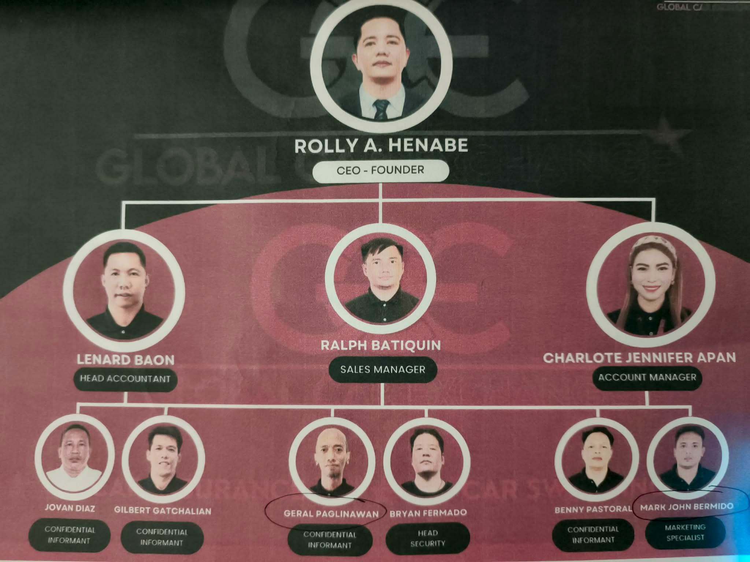

Figure 1. Organizational Chart of _______

Figure 1 described the organizational chart of the study.
Provide explanations on the figure

System Flowchart

A System Flowchart shows the solutions and the proposed flow from the existing system.
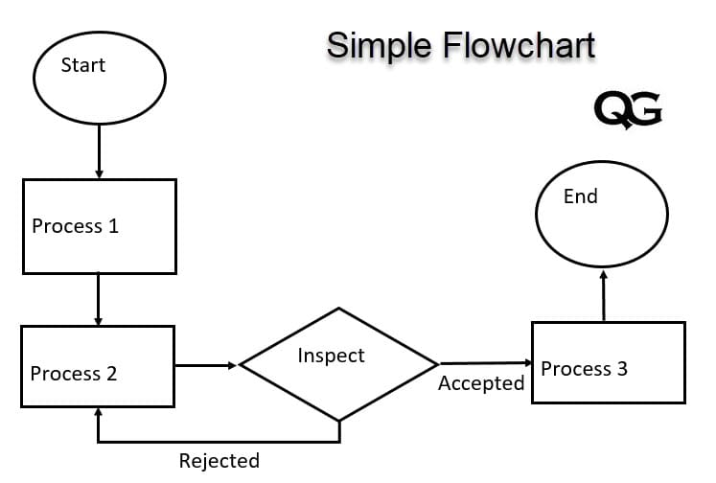
Figure 2. Login Page
Figure 2 shows the ………. Provide explanation of the flowchart

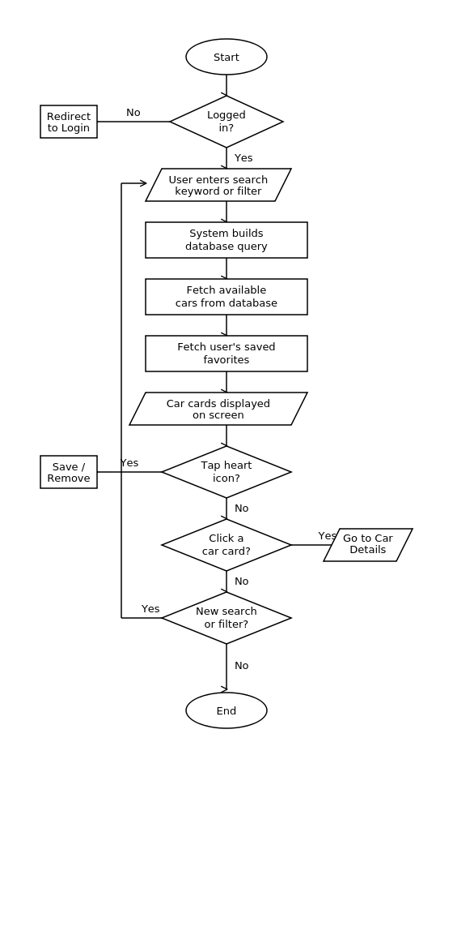
Figure 3. Browse Cars Page System of Global Car Exchange
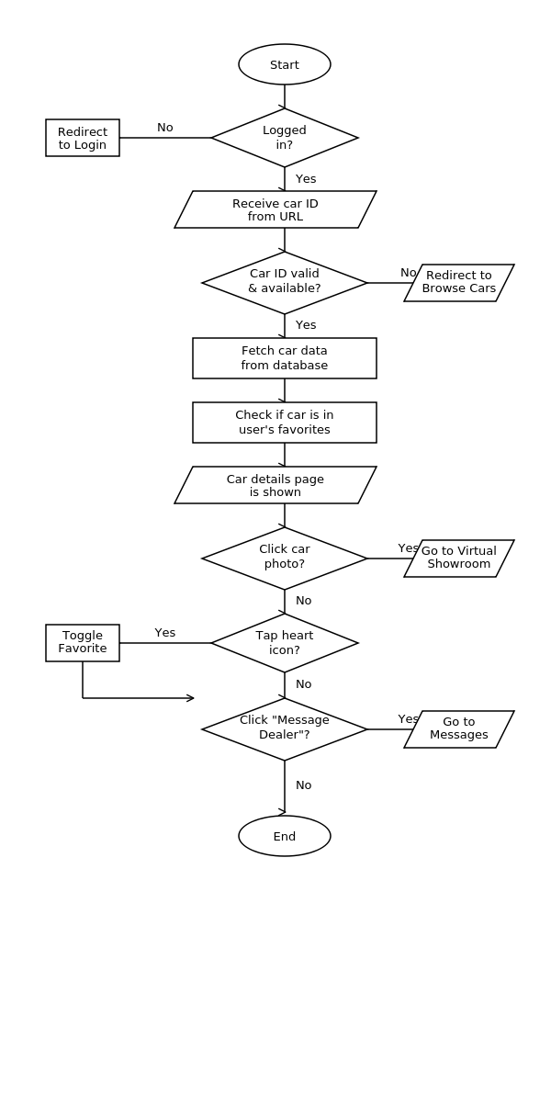
Figure 3 is a representation of the system flowchart showing the path of navigation for the Browse Cars Page of Global Car Exchange. The process begins by checking if the user is logged in; next is searching or filtering, then the system displays the searched results as well as favorites. From here, there is an option of saving favorites, removing favorites, checking details of the car, and searching, among other processes before reaching the End.
Figure 4. Car Details Page System of Global Car Exchange
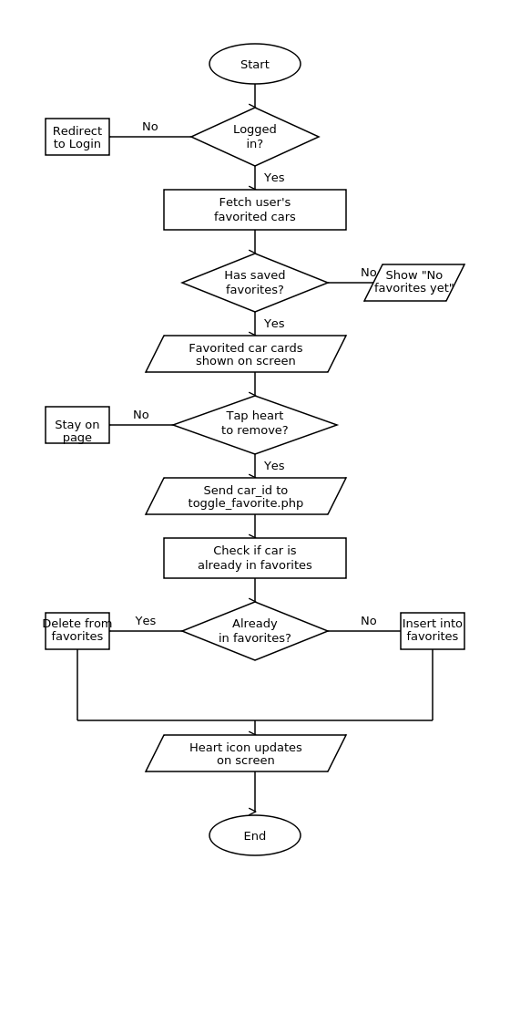
Figure 4 is a system flowchart that describes the navigation path for the "Car Details Page" of "Global Car Exchange." The process starts at verifying user login and validating car ID, and then it retrieves and displays car information along with favorite status. After this step, users can view the virtual showroom, manage favorites, and/or message the dealer, and this process will end if no further actions are taken.

Figure 5. Favorites Page System of Global Car Exchange
Figure 5 is the system flowchart that explains the process of favorites management for the Favorites Page of Global Car Exchange. When the user logs in to the system, all of the user's saved favorite cars are retrieved from the database and displayed on the screen. If there are no favorite cars saved, "No favorites yet" is displayed on the screen instead. When the user clicks on the heart icon of any car card on the screen, the car ID is sent to toggle_favorite.php to remove the car from or add it to the favorite car list, and the heart icon on the car card is immediately changed to reflect this update.

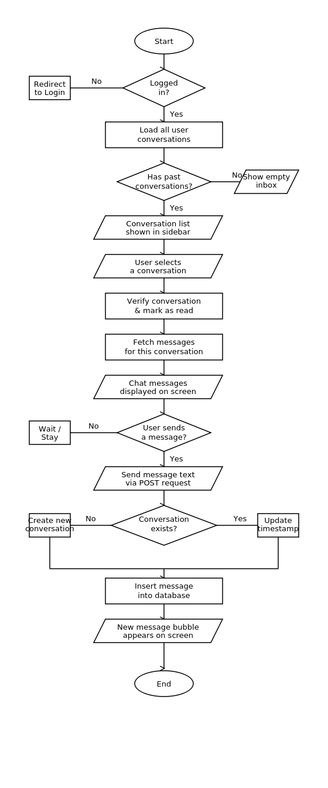
Figure 6. Messages Page System of Global Car Exchange
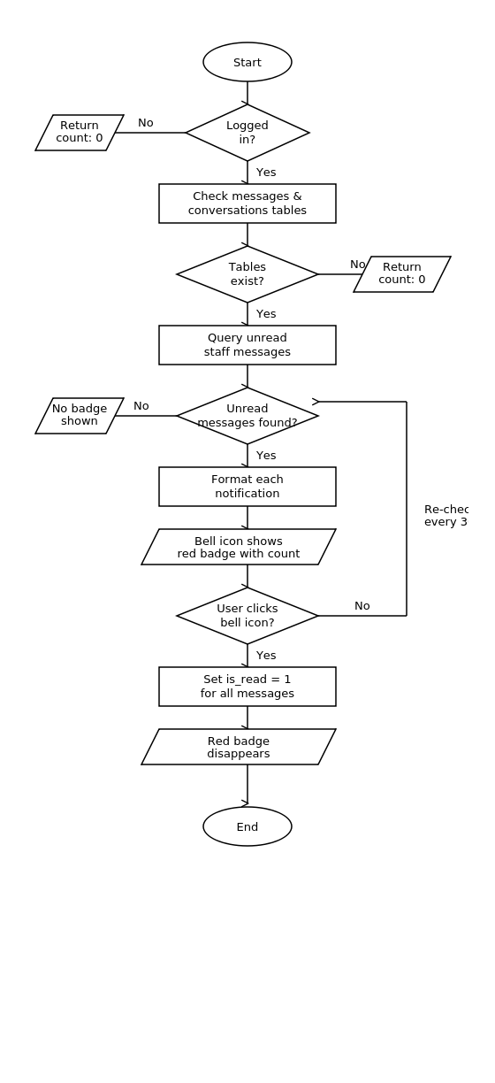
Figure 6 depicts the system flowchart for the messaging process for the Messages Page of Global Car Exchange. Once a user logs in to this system, all available user conversations will be displayed in the sidebar, and the user will be able to view messages on screen for a chosen conversation. However, if no conversation is available, the user will see an empty inbox. Once a user sends a new message, it will be posted to the server and stored in the database, updating or creating a new conversation timestamp, and the new message bubble will be displayed on screen.

Figure 7. Notifications System of Global Car Exchange
Figure 7 is the system flowchart that explains the process of notification for Global Car Exchange. The system checks whether the user is logged in and whether there are tables for messages and conversations in the database. If any of these conditions are not met, the system will show 0 count and no notification. When there are unread staff messages, the bell icon will show a red badge with the count of unread messages. When the bell icon is clicked, all messages will be marked as read and the red badge will disappear.

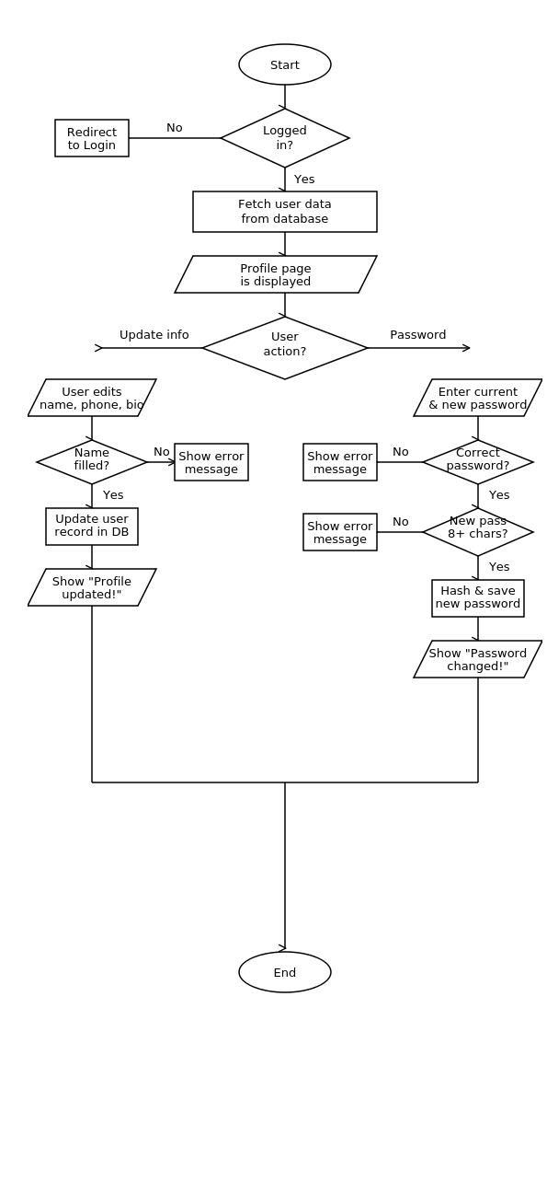
Figure 8. Profile Page System of Global Car Exchange
Figure 8 is the system flowchart that demonstrates the system for managing the profile management process for the Profile Page of Global Car Exchange. After logging in to the system, the system will prompt the user to update their profile by entering their name, phone number, and bio. The system will also prompt the user to update their password. Both processes will have validation checks. The name field should not be empty if the user wants to update their profile. The new password should be at least 8 characters long and should match the current password.

Data Flow Diagram

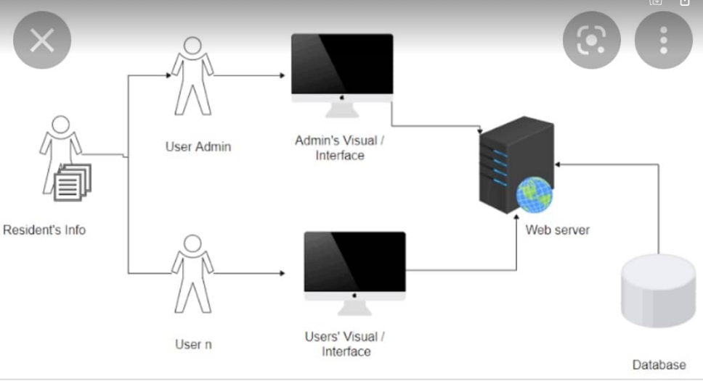

Figure 3. Data Flow Diagram of the Proposed System
Figure 3 shows the ………. Provide explanation of the figure

System Architecture



Figure 4. System Architecture of the Proposed System
Figure 4 shows the ……….

